* 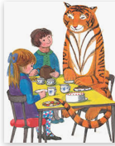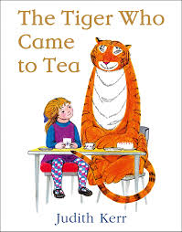[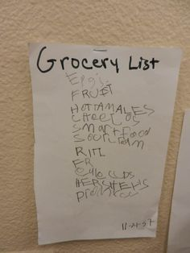](https://www.google.com/url?sa=i&url=https%3A%2F%2Fwww.pinterest.com%2Fdrtsliteracy%2Femergent-writing%2F&psig=AOvVaw07C2Z3wCoGcDQRrO6sSzDE&ust=1585918273509000&source=images&cd=vfe&ved=0CAIQjRxqFwoTCLjAzY_kyegCFQAAAAAdAAAAABAD)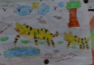

5/6

* Play on [Times Table Rock Stars](https://ttrockstars.com/) or use the
* times table grids to practice your skills.
* Bake scones – how many would you need for your

family? Does your recipe need to be altered? What

if 4 friends were coming round? How would you alter the recipe? What if you were baking scones for 20 people – what would change then?

* Create a weekly budget for feeding a hungry tiger. What would he need to eat and how much would it cost?
* Get your child to work on their reasoning and problem solving by [practising past SATs questions](https://primarysite-prod-sorted.s3.amazonaws.com/springcroft-primary-school/UploadedDocument/915522a464444cfa96a70bc9bdaee45d/ultimate-ks2-maths-sats-organiser-y6-daily-mini-videos-puzzles-for-y5.pdf) that are broken down into topic areas and have videos linked to them that can be watched if needed. As these are older papers, these are suitable for both years 5 and 6. Click on one of the topic areas listed to gain access to the questions.
* [Daily arithmetic for different areas of maths](https://www.topmarks.co.uk/maths-games/daily10). Your child should aim to work on level 4, 5 and 6 activities.
* From a 2L bottle of pop how many glasses could you fill if the glasses were 250ml? 125ml? 1pint?
* Write a report on a tiger – what is its diet? Habitat? What conservation is happening to help the tiger?
* Write a letter to Prince Charles/Prince William detailing what is happening to the tigers and how we as a country could help.
* Make up a story similar to the tiger that came to tea. Who came to tea? What would happen? Would dad believe you when he got home?
* Create a newspaper article about the Tiger Who Came to Tea. Can you use quotes and interview Sophie and her mum? You could use Purple Mash to write up your newspaper (in 2write – 2publish +).
* Write a diary entry from one of the character’s point of view on the day the tiger came to tea. Who will you pick? How do you think the diary entries would differ depending on character?

Literacy Ideas

(try to do one activity a day)

Maths Ideas

(try to do one activity a day)

* Find out about Tigers. Where do they live? What continent are they on? What is happening to their habitat? What is being done to help them? Watch Lost Land of the tiger on BBC – an interesting documentary about tigers and what is currently happening.
* Endangered? Tourist attraction? Caged illegally? What are the different opinions of the use of tigers? What are pros and cons of all the habitats they are living in? What is your opinion of zoos?
* Draw a detailed map of the areas that you find tigers. Label countries,

continents mountain ranges etc

* Sketch a tiger – concentrate on the details of fur – how can you make

it look real? Think about sketching and shading to create a 3D effect.

* Find out the difference between Siberian Tigers and Royal Bengal Tigers – can you find out why they are called royal? Are there any other subspecies of tiger?
* Can you create a database on Purple Mash about the different species of tiger you have found?
* Can you think of the rules you would have for your team party? How would you share them with the tiger? Written word? Code for tiger? Number codes to work out? Actions in pictures? Can you use a key to communicate to the tiger?
* Research and plan an afternoon tea menu – what would you offer? How much would you need? How big would your cake be? What drinks would you serve? Could you make your afternoon tea for your family?
* Can you design a cardboard chair strong enough for a tiger to sit on? Think about how you would join the pieces together and which shapes would be best for strength.
* The Tiger Who Came to Tea was written a long time ago – what clues in the story tell us this? How is it different to now? What about the roles of mum and dad are they still the same today? Is there anything in the story that you would still like to happen today?

The Wider Curriculum

<https://www.youtube.com/watch?v=BXgW9UCgpc8>

KS1