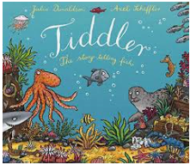
Year 5 and 6
https://www.youtube.com/watch?v=qcTQADUywZY
- Research one of the creatures in the story and write a report about it. What does each creature eat? How does it move? How is it adapted to help it live underwater? Are all underwater habitats the same?
- Investigate floating and sinking. How do fishing boats stay afloat? What materials and shapes are the best to use when designing a boat? What forces help the boat float/make the boat sink? How could you add more buoyancy to a boat? How do boats avoid capsizing when hauling fish in?
- Tiddler sees some flying fish while he is having his adventure. Watch this video to learn more about them:
- Find the locations of ponds / rivers / lakes near to where you live. Can you describe how a river is formed from source to mouth?
- Find out about fishing and how it affects people and the environment. What is meant by sustainable fish?
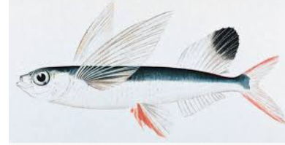
- Investigate any environmental issues linked to the sea. How does pollution affect sea creatures? How can people help ocean habitats?
- Find out about sea food chains and which other creatures would eat the fish in the story - create some food chain diagrams. Can you extend this into a food web?
- Make a classification key for sea creatures. What questions could you ask to help you sort them into groups?
Maths Ideas (try to do one activity a day) | Literacy Ideas (try to do one activity a day)
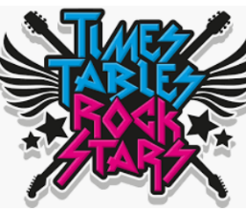  - Play on Times Table Rock Stars  - What times are mentioned in the story? Are there any clocks in the illustrations? What times do they show? Practice telling the time to the nearest minute.  - Get your child to work on their reasoning and problem solving by practising past SATs questions that are broken down into topic areas and have videos linked to them that can be watched if needed. As these are older papers, these are suitable for both years 5 and 6. Click on one of the topic areas listed to gain access to the questions.  - Daily arithmetic for different areas of maths. Your child should aim to work on level 4, 5 and 6 activities.  - How do we measure liquid? What are the common units of measurement used? What would we use to measure liquid in a cup? On a spoon? In a bucket? In the sea? In a pond? Can you use some containers in your house and estimate then measure how much liquid they can hold? | - Research one of the creatures in the story and write a report about it. What does each creature eat? How does it move? How is it adapted to help it live underwater?  - What lessons might the fish have at their school? Write a diary entry from the point of view of one of the fish, giving their thoughts about their lessons at school.  - Create a similar style story but in a different habitat with different animals  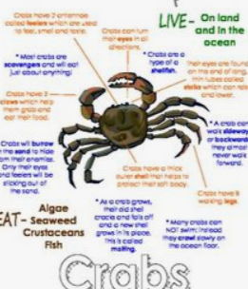  - Make up an alternative ‘adventure/tall tale’ that Tiddler might tell. How would he explain this to his teacher?  - Imagine that you could go diving underwater. What might you see? What words could you use to describe things? What adventure might you go on?  - Write a balance argument about fishing or other environmental issues linked to the sea.

