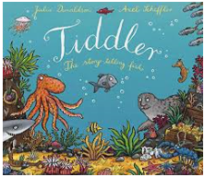
Year 3 and 4
https://www.youtube.com/watch?v=qcTQADUywZY
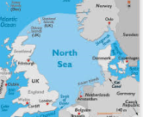
- Look at the illustrations and identify and find out more about some of these creatures
- Create a 3D shoe box under the world scene
- Tiddler sees some flying fish while he is having his adventure. Watch this video to learn more about them
- Investigate floating and sinking. How do fishing boats stay afloat? What materials and shapes are the best to use when designing a boat?
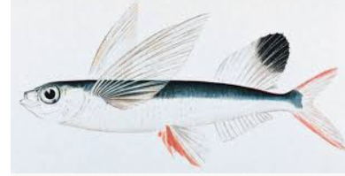
- Tiddler sees some flying fish while he is having his adventure. Watch this video to learn more about them: https://youtu.be/gAjzH0vWSIA
- Look on a map and find different seas and oceans around the world.
- Find out about fishing - how does it affect people and the environment?
- Find out about food chains under the sea and which other creatures would eat the fish in the story - create some food chain diagrams.
Maths Ideas (try to do one activity a day) | Literacy Ideas (try to do one activity a day)
- Play on Times Table Rock Stars  - What times are mentioned in the story? Are there any clocks in the illustrations? What times do they show? Practice telling the time to the nearest minute.  - Practice counting in 3s, 4s and 8s  - Practice making numbers 10 and 100 times bigger and 10 and 100 times smaller.  - Practice writing your numbers in words.  - Go on a shape hunt around the house, how many 2D and 3D shapes can you find? Can you describe the properties of them? | - Research one of the creatures in the story and write a report about it. What does each creature eat? How does it move? How is it adapted to help it live underwater?  - What lessons might the fish have at their school? Write a diary entry from the point of view of one of the fish, giving their thoughts about their lessons at school.  - Create a similar style story but in a different habitat with different animals  - Make up an alternative ‘adventure/tall tale’ that Tiddler might tell. How would he explain this to his teacher?  - Write some sentences from the story that could use inverted commas (speech marks)  - Practice some words from the Year 3 and 4 spelling grid  - Use 2Animate or 2Create A Story on Purple Mash to re-create the Tiddler story or your own version.

