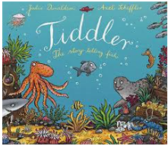
EYFS
Curriculum and Life Skills
https://www.youtube.com/watch?v=qcTQADUywZY
- Listen to the story lots of times and encourage children to join in repeated words and phrases
- Draw an underwater sea scene and draw some of the sea animals Tiddler claims to have met
- Look at the illustrations and identify and find out more about some of these creatures
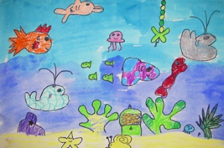
- Use painting software or purple mash to create an underwater scene.
- Draw or paint an underwater scene.
- Create some Lollipop Stick characters to help retell the story
- Create a 3D shoe box under the world scene

Maths Ideas (try to do one activity a day) | Literacy Ideas (try to do one activity a day)
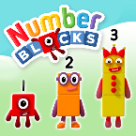  - Watch a Numberblocks clip each day at: BBC​ or ​CBeebies  - Sing Number songs to practice counting, reciting numbers in order, one more, one less using number songs: Five Little Ducks, Five Little Men, Ten Green Bottle  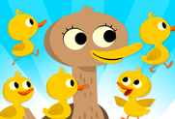  - Practice recognising amounts up to ​five​ or up to ​ten​ by playing these games. This can be done by reading a dice when playing board games, playing with cards, identifying how many food items on the plate etc.  - Next time you open a packet of raisins or carrot sticks, count out how many you have. Can you write the number?  - Write 0-20 on some building bricks and see if you can put the numbers in the correct order to build the tower. | - Watch your child’s RWI Phonics Session on you tube  - Children to read to parents daily. Visit Oxford Owl for free eBooks that link to your child’s book band. You can create a ​free account​. Your child could share a book everyday. This can be reading a book aloud everyday or sharing a book with an adult.  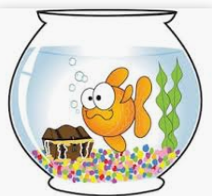  - Identify all of the rhyming words that are used in the story. Can you think of other words that rhyme with these?  - Together write a set of instructions teaching people how to look after some goldfish.

