Eden Camp

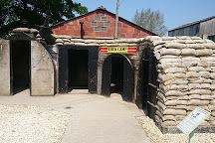
During World War II, Italian prisoners would get sent to a prisoner of war camp like Eden Camp. Each hut now has an experience different for each one. They had information about the Second World War and had scenes to make you feel like you are in the war.

My Favourite Hut

Even though each hut was amazing, the best one in my opinion was hut number 3 The U-Boat Menace. U-Boat Menace felt like you are in a U-Boat. U-Boats are a submarine that were used in the war to sink enemy ships carrying goods that would help the win. U-Boat Menace simulates being in a U-Boat with the floor rocking side to side being dim and eerie.

The Air Raids

During the war, they built sirens named Air Raid Sirens. If they heard them sound, they had to run to the nearest Morrison Shelter to be safe. They had to do this because if the siren sounded the opponent`s planes have come to drop bombs. This would be worse if they lived in a place like Stocksbridge because Stocksbridge made steel for planes. Stocksbridge still makes steel today! London was also important because the monarch lived there. In fact, today London still has a monarch!
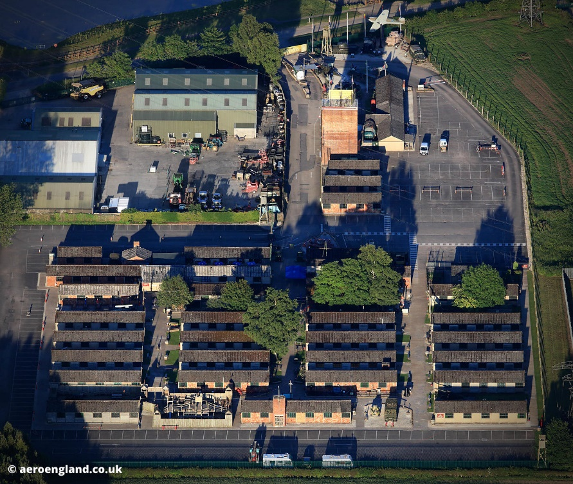
My Other Favourite Area Of Learning

I am not sure fully, but my other favourite area of learning was hut 20 AFS and Bevin Boys. In that hut, there were 2 firemen rescuing a baby and a lady. It even had sound effects! There was a house on fire and the lady with the baby stood upstairs with the room burning and one of the firemen was stood on a ladder up rescuing them!

Eden Camp was one of my favourite trips and was brilliant! I would recommend anyone to go here and see all of the huts we did not see all of the huts but I am sure I will visit again to Eden Came some time again.
By Sam

