Eden Camp
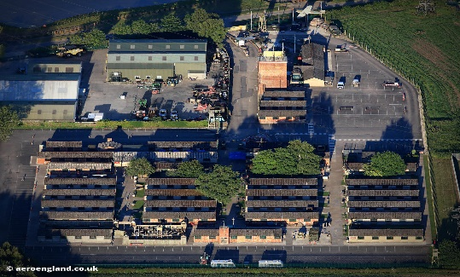
Eden Camp is a prisoner of war camp during World War 2. Some of the huts were dark and terrifying but there were neatly lined up in rows. Each hut had a different theme linked to one and another. The prisoner of war camp was a museum in North Yorkshire, it was quite a long journey!

My favourite hut
My favourite hut was hut number 4, the U boat menace. The U boat menace was a submarine that went under water during war. I liked this hut because it showed us lots of interesting information. Inside this hut, it showed us what it was like inside the U boat menace (a submarine). It contained different amounts of seats, also some of the boats were larger than others. This would have made me feel anxious because you would have heard all the bombs going off. These people must have been used to it unlike us.
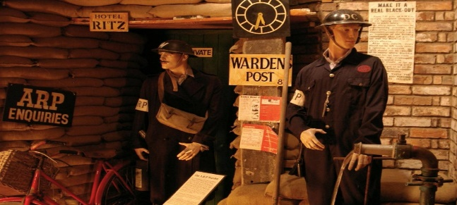
The Air Raids
The air raids, (which were linked to the Blitz) were bombs that constantly kept going off. ARP wardens had to come and help children if they were in danger or hurt after the bombs went off. To help people breathe, they used gas masks, because if they didn’t they might have not survived. The German Luftwaffe kept sending bombs down from the air so people had to be careful. During the air raid sirens, when the air raids went off people hurried into Anderson and Morrison Shelters.

My other favourite area of learning
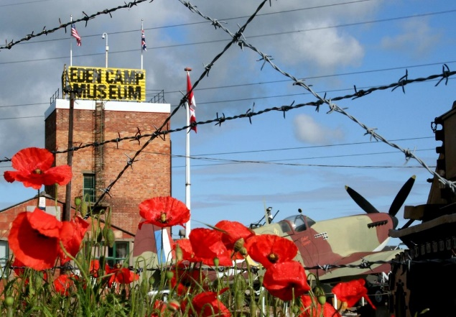
My other favourite area of learning was the puppet show (which was Hut 6). I especially enjoyed this hut, because it was really funny also we got wet as they kept throwing water at us, so everyone kept laughing! The songs they sang were very famous from World War 2. They told us lots of interesting facts. This hut was amazing!
Eden Camp, is a very immersive area to learn about World War 2. This trip is for families as well as schools. This trip was definitely worth it. It is a museum were you can learn lots of facts, (mostly about the wars of the past). Next time, I would like to explore all the huts as we didn’t0 get round to the all. Also I would like to play in the adventure playground that was there too.

By Ruby

