Mikey Tuesday 25th September

Eden Camp-Hot Write

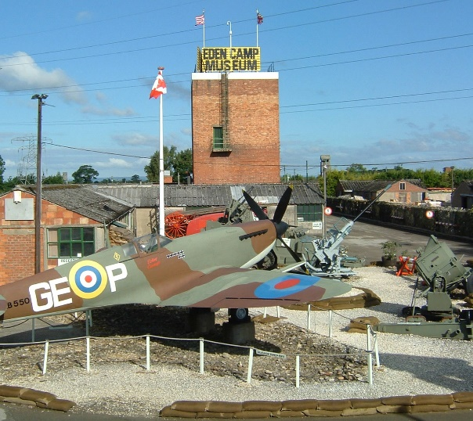
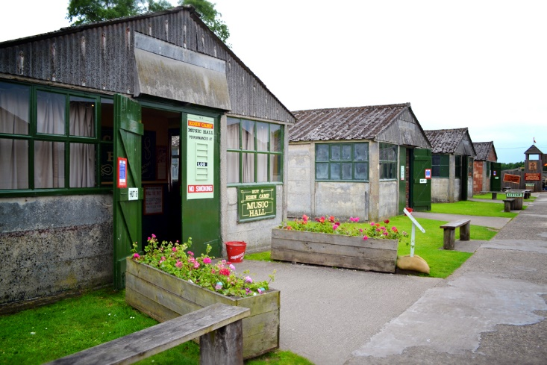

Last week year 5 went to Eden Camp (prison of war Camp) which is now a museum. Also there are 29 huts each hut has their own themes. They have sub-headings so they know what the hut is about such as the Blitz, The Great Escape and women at war.

Gas Masks and Blitz
Back in WWII you had to turn all lights off so the Axis side wouldn’t see England. If we didn’t turn the lights off they could off bombed every city in United Kingdom. In WWII they dropped smoke bombs every were .So you had to take your gas mask everywhere you went to keep safe.

Prisons
In WWII prisons were the main things in WWII. Manly Italians were in our prison. In Japan prisons they starved you gave you gas and you also got hit with the back of a rifle gun

Women at war
Although men had to work woman also did. They made bullets, guns, hatchets and many more weapons. They worked in cellars and bunkers. With the spare materials they made spitfires.

Eden Camp is a spectacular place. I think you should go there for the day. I hope I visit soon or when I’m older.

