Home Learning Projects
1 – Our Family
KS1
Maths Ideas (try to do one activity a day) | Literacy Ideas (try to do one activity a day)
- Play on ​Hit the Button​ - number bonds, halves, doubles and times tables.  - Practise counting in 2s, 5s and 10s. This ​game​ could support this.  - Work on a shopping list for the weekly shop and get children to add up how many items and add up the cost of some items. This ​game​ could support work on making amounts of money.  - Practise telling the time. This could be done through this ​game​ (scroll down to access the game). Read to the hour and half hour.  - Write the numbers 0-20 in words and digits. | - Children to read to parents daily. Visit Oxford Owl for free eBooks that link to your child’s book band. You can create a ​free account​. Your child could share a book everyday. This can be reading a book aloud everyday or sharing a book with an adult.  - Listen to a story read ​Storytime​  - Family – look a family in a story - how are they the same/different to your family? Can you write sentences comparing the two families?  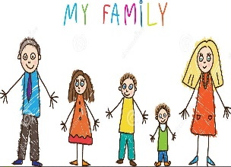  - Ask them to pick their favourite poem or write a poem https://www.poetry4kids.com/topic/famil y/  - Write a postcard - find out about different postcards and why people write them. Can they design the front of the postcard and then plan what to write and who they could write it too.
Curriculum and Life Skills
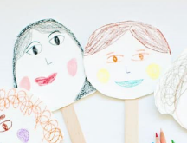
- Self portrait: - Ask your child to think about which materials they use to draw? Can they find different materials around the house to help? ​Ideas
- Design a personal coat of arms shield for the family - Find out what a coat of arm shield means. Ask them to begin to think about their design. What could they draw? What does it mean to them ? Ask them to think about the colours and shapes. Maybe if they have some cardboard around the house they could make a shield to give to a family member.
- Create a booklet all about the family - Can they name the people in their family and write sentences about them? Who are they? What do they call them? What do they like or dislike? Why are they special to them? Maybe they could get a photograph or draw a family member before they write about them.
- Interview a family member - interview a family member that doesn’t live at home with them. Allow your child to ask them about their childhood. Who did they live with? Who is in their family? Have they got any family traditions they follow and why.
- Have a family pic nic in the garden and prepare the food and settings together. Can they find out and prepare favour ite snacks/meals for their family or write a menu for everyone to make their own orders?

