Eden Camp
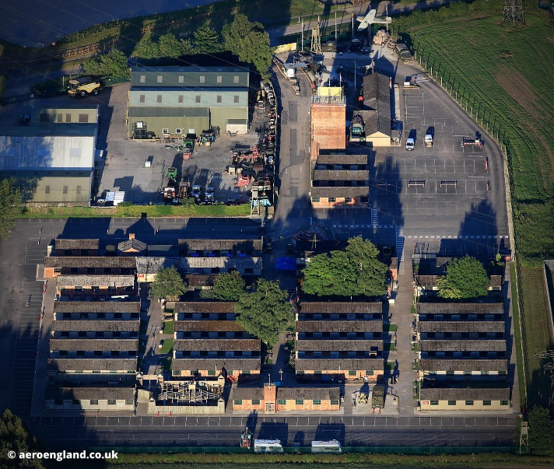
Eden Camp was a PoW camp during World War 2 each hut had a different theme. Some huts were dark and scary.
My favourite hut
Hut number 7 was my favourite hut. It was the street at war. My favourite was the sweet shop because it showed what they ate back then.
The Air Raids
The Morrison shelter was small. The Blitz was scary because it was very dark and it was smelly inside the hut.
Eden Camp is a good learning experience for studying World War 2 lots to see and do.

By Jack B

