Home Learning Projects
1 – Our Family
EYFS
Maths Ideas (try to do one activity a day) | Literacy Ideas (try to do one activity a day)
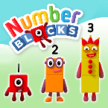  - Watch a Numberblocks clip each day at: BBC​ or ​Cbeebies  - Work on purple mash  - Practice counting up to 20. This can be done through playing hide and seek, singing number songs, chanting, board games etc.  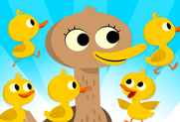  - Practice recognising amounts up to ​five​ or up to ​ten​ by playing these games. This can be done by reading a dice when playing board games, playing with cards, identifying how many food items on the plate etc.  - Sing Number songs to practice counting, reciting numbers in order, one more, one less using number songs: Five Little Ducks, Five Little Men, Ten Green Bottle | - Reception age children: Children to read to parents daily. Visit Oxford Owl for free eBooks that link to your child’s book band. You can create a ​free account​. Complete the linked Play activities for each book.  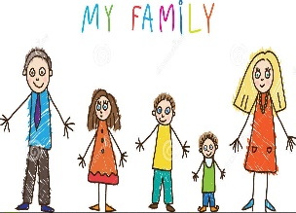  - Ask your child to draw a picture of the people who live in their house. If they share time across two houses, draw who lives in each house. Can they label their family members using their phonics knowledge?  - Practice name writing. Can they write their first name? Middle name? Surname?  - Practice forming the letters of the alphabet. Follow your school’s script.
Curriculum and Life Skills
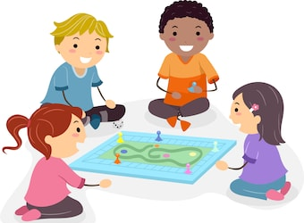
- Look at a selection of family photographs​ and discuss the changes over time.
- Draw a family tree​- How does your family link together? Can your child draw out their family members and link them together using lines?
- Play a family board game-​ ​Play a game together. Talk about taking it in turns and playing fairly. Dice games will support your child’s number recognition. You could use a spinner with numerals on to help develop numeral recognition. If you don’t have a spinner you could make one using an old cereal box and a split pin
- Have a family picnic.​ Lay out a blanket in the living room or garden. Can children make sure everyone has a plate, fork, spoon, and cup? How many do we need all together? Give your child a selection of food and ask them to share it fairly between everyone? If there is one left, over what could we do?
- Sort out the clean clothes.​ Who do they belong to? Can they deliver them to the right place in the house? Pair up socks. Can they match the patterns/ colours? Can they count in twos to work out how many there are all together? Peg clothes on the airer (this will support children to develop hand strength, which will impact on their writing).

