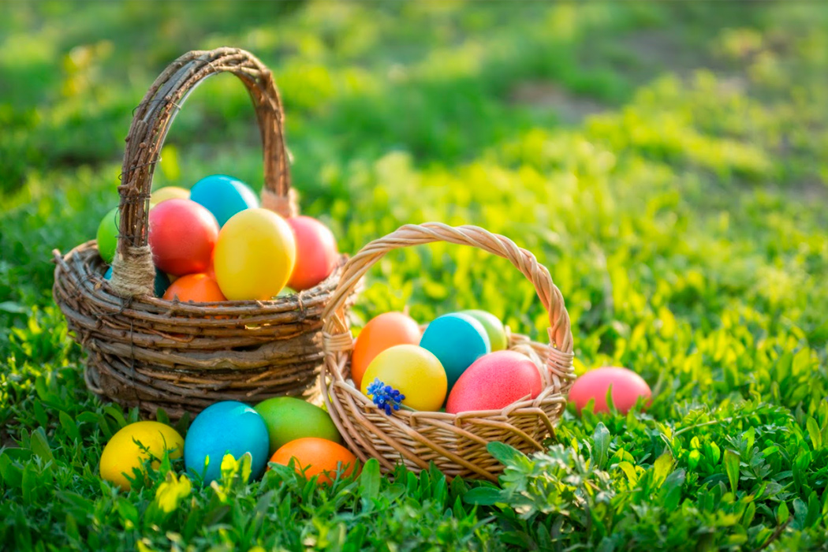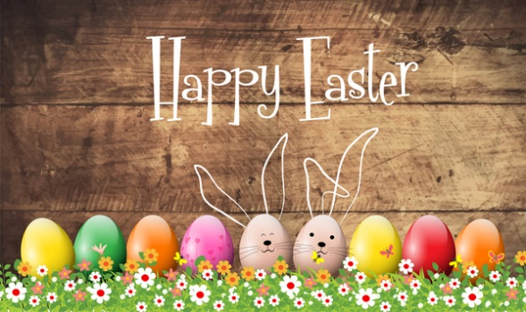

Design and make your Easter Egg for the Easter Egg challenge – decorate it in any way you would like then send a photo on dojo to your teacher.

Design and make an Easter Card for your family.

Design and make an Easter basket, can you use your maths skills to draw accurately your net, is this going to be a cube, cuboid or a more unusual 3D shape?

Looking at the life cycle of plant, animals, can you create one. You could use props, film them, draw it and then make a short film about how it works. Make an explanation to a younger audience to understand.

Can you look at recipes for a traditional Easter. Ask family for a vote, which would be favorite? Can you design and make the favourite meal?

Outdoor Activities

What are the signs of spring? Whilst outside or on a walk, what signs can you see? What are the names of the growing plants?

What different birds can you see/hear? Can you describe the different noises of them through observing them?

Can you create an orienteering task in your house/garden with clues for objects? Can someone in your house complete the course and evaluate the clues?

Can you design an egg and spoon race, what obstacles have you used? What skills do you need to complete the course?

Take phots on your walk and then sketch the signs of spring/birds based on your observations.

Help adults at home in the garden, pick weeds, cut the grass, sweep the concrete and have a tidy.

* Listen to the Easter Story - <https://www.youtube.com/watch?v=Wnbo2AmS3OI>
* Whose side would you have been on? Explain your reasoning.
* Can you understand why Jesus was betrayed? Write a letter from Judas explaining his reasons.
* What do we learn, regardless of our beliefs, from the story of Easter? Create a poster to advertise the positives of following these rules.
* Research why we have the symbols of Easter and write a short explanation as to what each one meas.

Useful websites:

<https://www.topmarks.co.uk/Easter/>

- for activities about Easter customs and traditions, as well as the Easter story

<https://www.activityvillage.co.uk/easter>

- downloadable colouring activities and lots more

<https://www.hearthandmade.co.uk/free-printables-for-easter/>

- free printables for Easter

<https://www.teachstarter.com/gb/blog/free-funky-easter-egg-craft-activity-gb/>

- Free Easter resources  
<https://www.twinkl.co.uk/search?term=easter>

Any other ideas…

Year 5/6

Easter Crafts