Bradley Tuesday 25th September 2018
Hot write-report on Eden Camp

2 weeks ago we visited Eden Camp we learnt a lot like WWII started in 1939.Did you know that Eden Camp in WWII was a prisoner of war camp. Each cabin contains a sell but now it’s a big garden with a row of 29 cabins. Each cabin now contains a different theme my favourite cabin is the blackout cabin. I learned in that cabin that the blackout started lots of bombers came. So they had to put extreme black curtains and no light to be seen.
Shelters
If your home was clasping you had a Morrison shelter. You climb in and anything that falls on you you’re safe from. An Anderson shelter is where you climb in and no bombes can hurt you and you sit and wait for the radio to tell you when to come out.
The children
Some children got sent away because of the bombing and picked up by strangers. Some lucky children had relatives that lived in the country side so they could live with them.

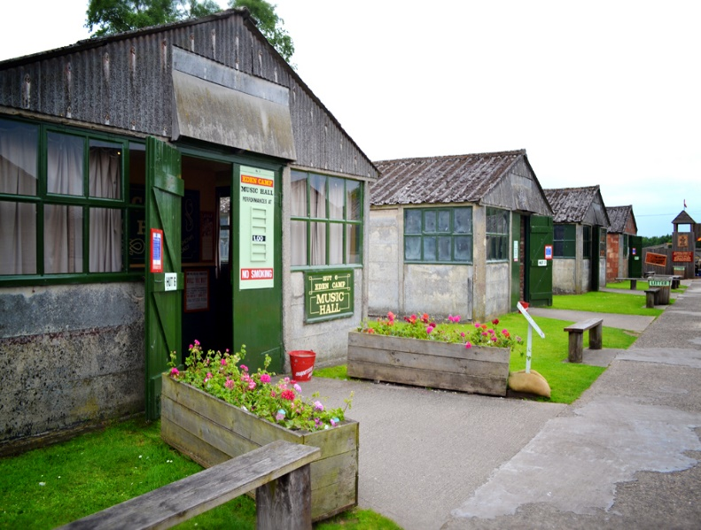
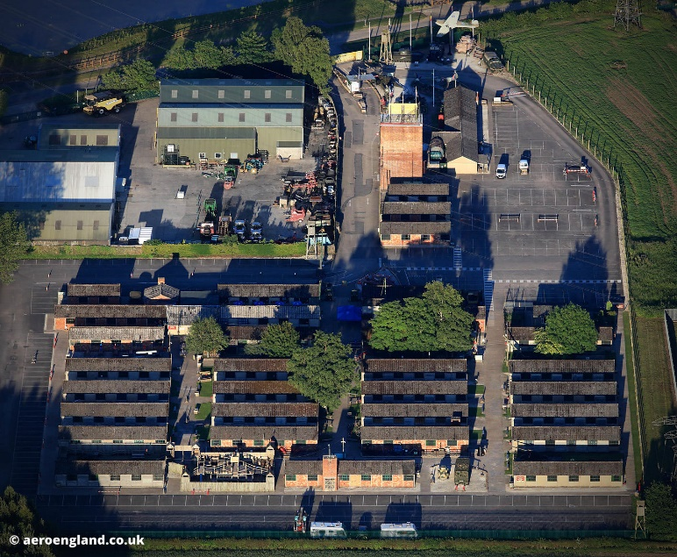
I really enjoyed my visit to Eden Camp I recommend everyone goes one day.

