* 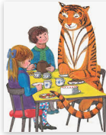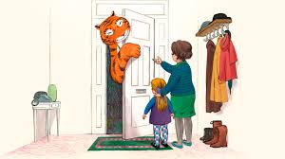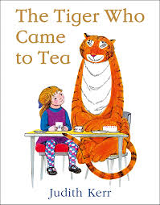[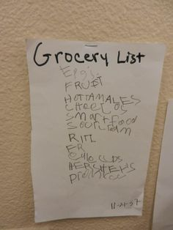](https://www.google.com/url?sa=i&url=https%3A%2F%2Fwww.pinterest.com%2Fdrtsliteracy%2Femergent-writing%2F&psig=AOvVaw07C2Z3wCoGcDQRrO6sSzDE&ust=1585918273509000&source=images&cd=vfe&ved=0CAIQjRxqFwoTCLjAzY_kyegCFQAAAAAdAAAAABAD)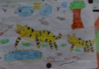
* Play on [Times Table Rock Stars](https://ttrockstars.com/)
* Make a menu of tasty food that Sophie’s family

can choose from the café with prices? Add

together the different costs. How much change would they get?

* Bake or cook something from your menu – help weighing out the ingredients carefully
* Practice counting in 50’s and 25’s
* Research the amount of kilograms of meat a tiger eats a day. Can you convert this to grams?
* Compare the weights of the different big cats. Why are the built the way they are?

Y3/4

* The Tiger Who Came to Tea was written a long time ago – what clues in the story tell us this? How is it different to now? What about the roles of mum and dad are they still the same today? Is there anything in the story that you would still like to happen today?
* Write a fact file on a tiger – Where does it live? What does it eat? Does anything eat tigers? Any other facts.
* Write a letter of invitation to a different animal, persuading them to come to your house for tea.
* Make up a story similar to the tiger that came to tea. Who came to tea? What would happen? Would dad believe you when he got home?
* Listen to the story being read on YouTube. Can you have a go at writing part of the story word for word to test your punctuation and spellings? Do you have capital letters and full stops in the correct places? Can you spot any fronted adverbials that need a

comma after them?

Literacy Ideas

(try to do one activity a day)

Maths Ideas

(try to do one activity a day)

* Find out about Tigers. Where do they live? What do they eat?

Are the endangered? Create a report using the information you

have found.

* Draw a tiger – concentrate on the patterns on their fur.
* If you could have anyone come to tea, who would it be and why?

What would you ask them? Write set of questions and tag the person in twitter to try and get some answers.

* Research and plan 2 healthy menus – A healthy menu for you

and a menu that would be suitable for a tiger.

* Where does this food come from? How does it get to our plates? Create a food map to show how different foods travel across the world/
* Use 2Paint on Purple Mash to create a label for a tin of tiger food.
* Can you think of the rules you would have for your tea party? How would you share them with the tiger? Written word? Code for tiger? Number codes to work out? Actions in pictures? Can you use a key to communicate to the tiger?

The Wider Curriculum

<https://www.youtube.com/watch?v=BXgW9UCgpc8>

KS1