* 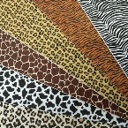[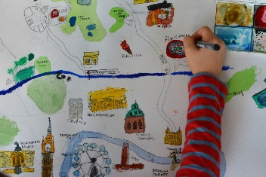](https://www.google.co.uk/url?sa=i&url=https%3A%2F%2Fwww.pinterest.com%2Fpin%2F3025924727640416%2F&psig=AOvVaw3jgQe4n-rMwvIIG7djF7a-&ust=1585320292106000&source=images&cd=vfe&ved=0CAIQjRxqFwoTCLjIpLuwuOgCFQAAAAAdAAAAABAD)[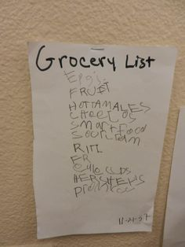](https://www.google.com/url?sa=i&url=https%3A%2F%2Fwww.pinterest.com%2Fdrtsliteracy%2Femergent-writing%2F&psig=AOvVaw07C2Z3wCoGcDQRrO6sSzDE&ust=1585918273509000&source=images&cd=vfe&ved=0CAIQjRxqFwoTCLjAzY_kyegCFQAAAAAdAAAAABAD)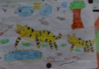[](https://www.earlyyearsresources.co.uk/science-c32/science-essentials-c399/graduated-beakers-set-p10855)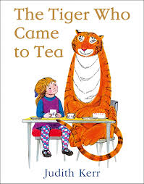

The Wider Curriculum

EYFS

* Listen to the story lots of times and encourage children to join in with parts of the story
* Find out information about Tigers. Where are they from? What do they really eat?
* Make sandwiches and have a ‘picnic’ with soft toys/figures
* Draw/paint a tiger, remember details such as whiskers, teeth and claws
* Draw a map to your house so the Tiger knows where you live and how to get there
* Use 3D google (search Tiger, scroll down to ‘view in 3D’ on mobile phone) and see a tiger in your

house!

* Create a menu for an imaginary Tiger tea party
* Look at animal prints and try and find repeating patterns e.g. tiger stripes, zebra stripes. Can you

create some animals with repeating patterns on them using paint/crayons?

Literacy Ideas

(try to do one activity a day)

Maths Ideas

(try to do one activity a day)

* Watch a [Numberblocks](https://www.bbc.co.uk/cbeebies/shows/numberblocks) clip each day at: BBC​ or ​CBeebies
* Sing [Number songs](https://www.youtube.com/watch?v=AXVytVHJblw) to practice counting, reciting numbers in order, one more, one less using number songs: Five Little Speckled Frogs, Five Little Monkeys
* Ask your grown up to write a number very slowly, shout out the number as soon as you think you know what it is! Swap and you have a go at writing the number
* If you make sandwiches for your picnic can you cut them all in half? How many pieces do you have if you cut something in half?
* Fill and empty jugs/cups and try and put them in order,

which holds the most? Which holds the least? Which is the

emptiest/fullest?

* [Watch your child’s RWI Phonics Session on you tube](https://www.youtube.com/channel/UCo7fbLgY2oA_cFCIg9GdxtQ)
* Children to read to parents daily. Visit Oxford Owl for free eBooks that link to your child’s book band. You can create a ​free account​. Your child could share a book every day. This can be reading a book aloud

everyday or sharing a book with an adult.

* Write a shopping list
* Make invitations or write letters inviting other

animals to tea. Which animals will you invite and

why?

* Once you have found out some information about

Tigers, create a poster telling other people about

them

<https://www.youtube.com/watch?v=BXgW9UCgpc8>